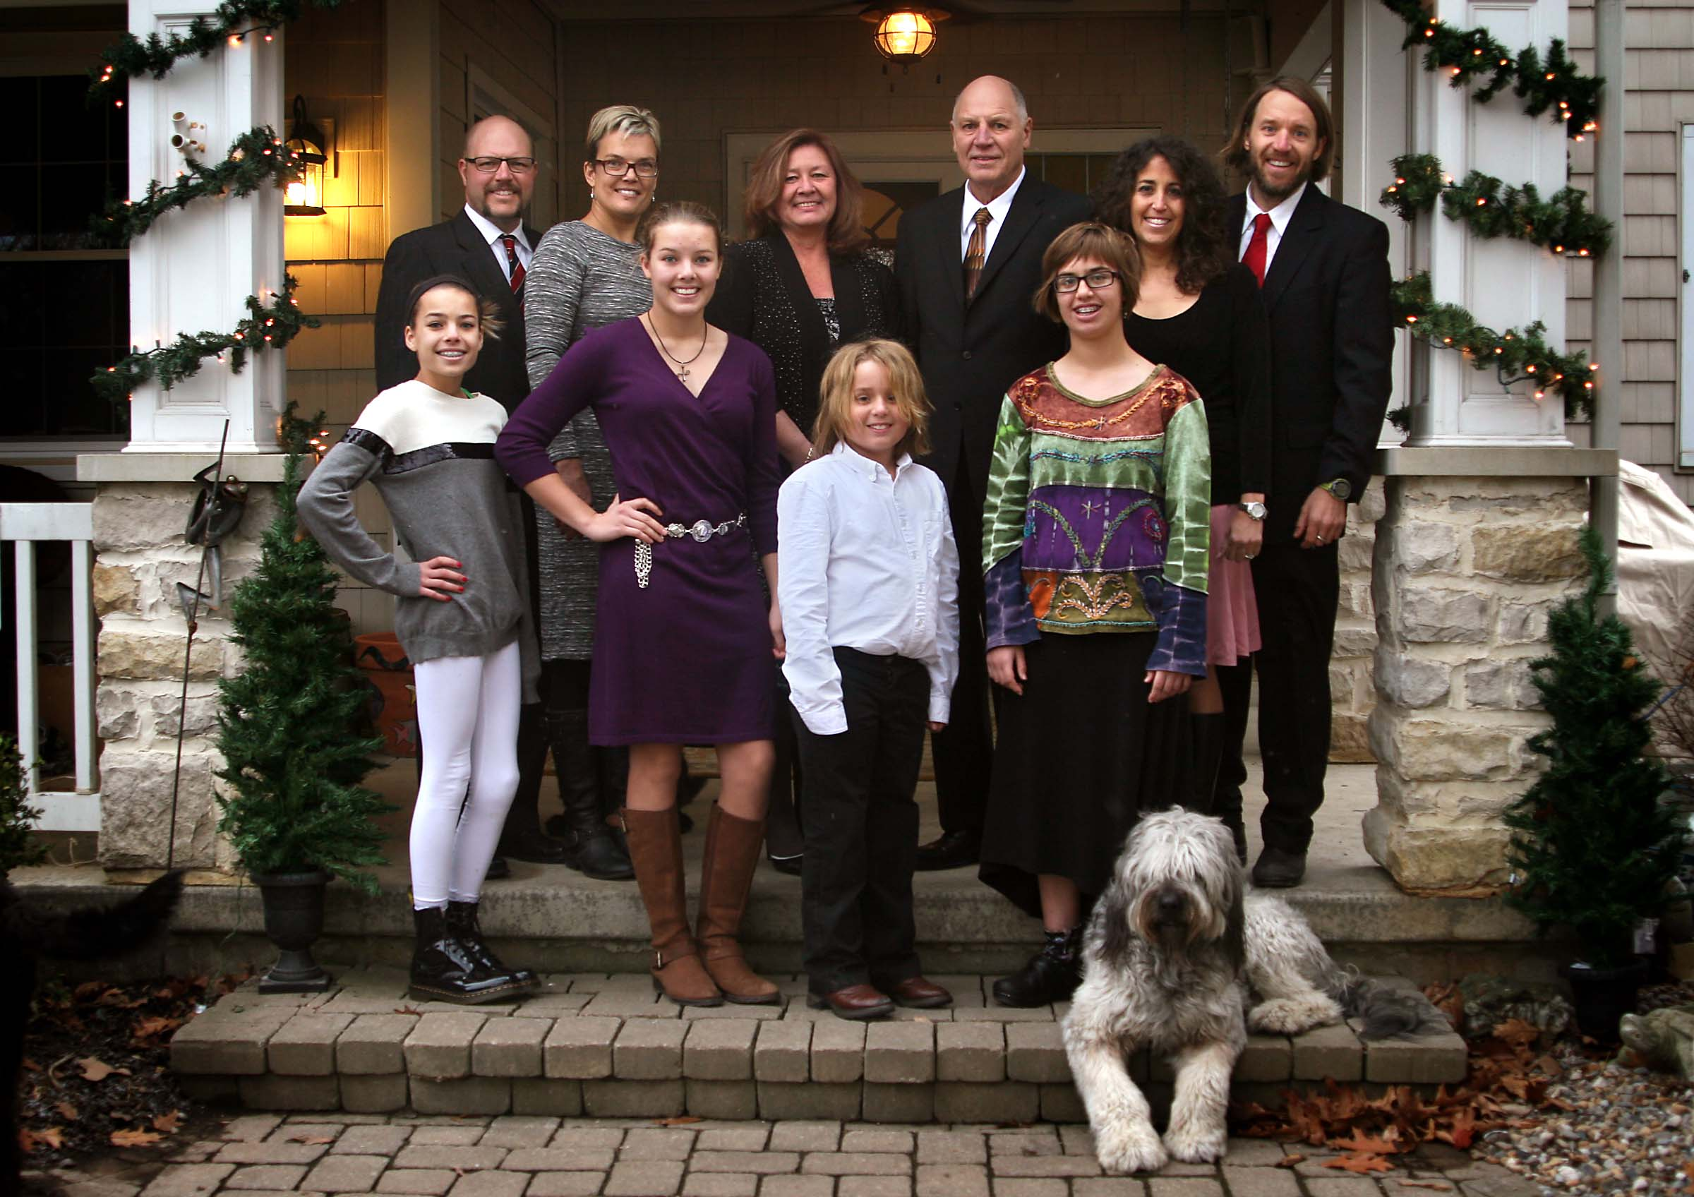

**l-r Back: Tyler Evans, Laura Harkness, Tamey Gail, John Earl, Gigi Highland, Aaron John [surname of all is Wolfe]**

**Front: Leah Harkness, Eryn Harkness, Russell Orion, Zoe Irene [surname of all is Wolfe]**

**Christmas 2013**

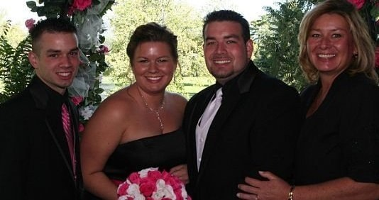

**l-r John Christopher Amon, Gail Marie Amon,**

**Joseph William Amon & Tamey Gail Wolfe**